# CS6140 Assignment4 Guanglei “Garrett” Wu

# 1. Perceptron and Dual Perceptron

1.2

According to the data, the two algorithms achieved nearly the same perfect performance:

|  |  |  |  |  |
| --- | --- | --- | --- | --- |
|  | Perceptron | | Dual Perceptron | |
| Train | Test | Train | Test |
| Accuracy | 100% | 100% | 100% | 99.8% |
| Precision | 100% | 100% | 100% | 99.6% |
| Recall | 100% | 100% | 100% | 100% |

### Data:

Perceptron:

Evaluation for training data:

Mean Accuracy: 1.0

Std Accuracy: 0.0

Mean Precision: 1.0

Std Precision: 0.0

Mean Recall: 1.0

Std Recall: 0.0

Evaluation for testing data:

Mean Accuracy: 1.0

Std Accuracy: 0.0

Mean Precision: 1.0

Std Precision: 0.0

Mean Recall: 1.0

Std Recall: 0.0

Dual Perceptron:

Evaluation for training data:

Mean Accuracy: 1.0

Std Accuracy: 0.0

Mean Precision: 1.0

Std Precision: 0.0

Mean Recall: 1.0

Std Recall: 0.0

Evaluation for testing data:

Mean Accuracy: 0.998

Std Accuracy: 0.004

Mean Precision: 0.996148202494

Std Precision: 0.00775625713068

Mean Recall: 1.0

Std Recall: 0.0

1.3

1,

We can see from below data, Linear Kernel Dual Perceptron only achieved about 60% accuracy, which tells it can **NOT** separate Spiral dataset.

### Data:

Dual Perceptron Linear:

Evaluation for training data:

Mean Accuracy: 0.642444444444

Std Accuracy: 0.0200049376621

Mean Precision: 0.656767944145

Std Precision: 0.0246759710545

Mean Recall: 0.600370904098

Std Recall: 0.0527430651257

Evaluation for testing data:

Mean Accuracy: 0.635

Std Accuracy: 0.038535697736

Mean Precision: 0.64881771244

Std Precision: 0.0456680540315

Mean Recall: 0.60223134415

Std Recall: 0.0609346057528

2,

According to below data, we can see that RBF Kernel Dual Perceptron generates good prediction for the Spiral dataset. Also we can see with different chosen of gamma, it seems the interval [0.05, 0.25] is a good gamma selection.

(Based on un-normalized data. It seems if choose to normalize data, we need to choose a much larger gamma to achieve the same performance)

|  |  |  |  |  |  |  |
| --- | --- | --- | --- | --- | --- | --- |
| Gamma | 0.01 | 0.05 | 0.10 | 0.15 | 0.20 | 0.25 |
| Train Accuracy | 92% | 100% | 100% | 100% | 100% | 100% |
| Test Accuracy | 92.6% | 99.8% | 100% | 99.6% | 99.9% | 99.9% |

### Data:

Dual Perceptron RBF: gamma = 0.01

Evaluation for training data:

Mean Accuracy: 0.920111111111

Std Accuracy: 0.0542501066734

Mean Precision: 0.957041364515

Std Precision: 0.0624242798041

Mean Recall: 0.888314585889

Std Recall: 0.109681390749

Evaluation for testing data:

Mean Accuracy: 0.926

Std Accuracy: 0.0486209831246

Mean Precision: 0.960852324861

Std Precision: 0.0548357618001

Mean Recall: 0.895141656135

Std Recall: 0.100850820693

Dual Perceptron RBF: gamma = 0.05

Evaluation for training data:

Mean Accuracy: 1.0

Std Accuracy: 0.0

Mean Precision: 1.0

Std Precision: 0.0

Mean Recall: 1.0

Std Recall: 0.0

Evaluation for testing data:

Mean Accuracy: 0.998

Std Accuracy: 0.004

Mean Precision: 0.998113207547

Std Precision: 0.00566037735849

Mean Recall: 0.998181818182

Std Recall: 0.00545454545455

Dual Perceptron RBF: gamma = 0.10

Evaluation for training data:

Mean Accuracy: 1.0

Std Accuracy: 0.0

Mean Precision: 1.0

Std Precision: 0.0

Mean Recall: 1.0

Std Recall: 0.0

Evaluation for testing data:

Mean Accuracy: 1.0

Std Accuracy: 0.0

Mean Precision: 1.0

Std Precision: 0.0

Mean Recall: 1.0

Std Recall: 0.0

Dual Perceptron RBF: gamma = 0.15

Evaluation for training data:

Mean Accuracy: 1.0

Std Accuracy: 0.0

Mean Precision: 1.0

Std Precision: 0.0

Mean Recall: 1.0

Std Recall: 0.0

Evaluation for testing data:

Mean Accuracy: 0.996

Std Accuracy: 0.008

Mean Precision: 0.996551724138

Std Precision: 0.0103448275862

Mean Recall: 0.996363636364

Std Recall: 0.0109090909091

Dual Perceptron RBF: gamma = 0.20

Evaluation for training data:

Mean Accuracy: 1.0

Std Accuracy: 0.0

Mean Precision: 1.0

Std Precision: 0.0

Mean Recall: 1.0

Std Recall: 0.0

Evaluation for testing data:

Mean Accuracy: 0.999

Std Accuracy: 0.003

Mean Precision: 1.0

Std Precision: 0.0

Mean Recall: 0.997777777778

Std Recall: 0.00666666666667

Dual Perceptron RBF: gamma = 0.25

Evaluation for training data:

Mean Accuracy: 1.0

Std Accuracy: 0.0

Mean Precision: 1.0

Std Precision: 0.0

Mean Recall: 1.0

Std Recall: 0.0

Evaluation for testing data:

Mean Accuracy: 0.999

Std Accuracy: 0.003

Mean Precision: 0.998148148148

Std Precision: 0.00555555555556

Mean Recall: 1.0

Std Recall: 0.0

# 2. Regularized Logistic Regression

2.1

No. Since lambda is used to prevent the parameters to grow very large, which causes over fitting problem. We add x0 and w0 only to shift the decision boundary. And all the x0 = 1, so it can’t be over fitting for w0.

2.2

Gradient is:

$$\frac{∂E}{∂W_{j}}=λW_{j}+\sum_{i=1}^{N}{\frac{1}{1+e^{-y_{i}W_{j}x_{ij}}}}\frac{∂e^{-y_{i}W_{j}x_{ij}}}{∂W_{j}}=λW_{j}-\sum_{i=1}^{N}{\frac{y_{i}x_{ij}}{1+e^{y_{i}W_{j}x_{ij}}}}$$

2.3

To implement regularized logistic regression, quite similar to normal logistic regression, only need to use regularized versions for cost function and gradient.

2.4

We have already developed data from last assignment for un-regularized Logistic Regression, so just copy the data from last. (Can also run Regularized with lambda = 0 to get Un-regularized version)

We can see from below comparisons, regularized versions have lower accuracy for training data, which is intuitive, since it limits the parameters to grow to fit the data. While since our un-regularized versions do not show over fitting problems, regularization does not improve the performance of test data.

### Spambase:

|  |  |  |  |
| --- | --- | --- | --- |
|  | Un-regularized | Regularized: Lambda = 100 | Regularized: Lambda = 500 |
| Train Accuracy | 91.9% | 91.0% | 89.8% |
| Test Accuracy | 91.5% | 90.8% | 89.7% |

### Breast Cancer:

|  |  |  |  |
| --- | --- | --- | --- |
|  | Un-regularized | Regularized: Lambda = 100 | Regularized: Lambda = 500 |
| Train Accuracy | 98.4% | 96.7% | 94.8% |
| Test Accuracy | 97.5% | 96.4% | 94.6% |

### Diabets:

|  |  |  |  |
| --- | --- | --- | --- |
|  | Un-regularized | Regularized: Lambda = 100 | Regularized: Lambda = 500 |
| Train Accuracy | 77.5% | 77.4% | 71.5% |
| Test Accuracy | 77.5% | 76.6% | 71.1% |

## Data:

## Un-Regularized:

### Spambase:

Evaluation for training data:

Mean Accuracy: 0.918594542381

Std Accuracy: 0.00210648592461

Mean Precision: 0.924624342506

Std Precision: 0.00280342992158

Mean Recall: 0.863828200311

Std Recall: 0.00375707763759

Evaluation for testing data:

Mean Accuracy: 0.915

Std Accuracy: 0.0126180624878

Mean Precision: 0.917958759762

Std Precision: 0.0186741495177

Mean Recall: 0.861744993047

Std Recall: 0.0223033673753

### Breast Cancer:

Evaluation for training data:

Mean Accuracy: 0.984015594542

Std Accuracy: 0.0014587358233

Mean Precision: 0.990371802316

Std Precision: 0.0021168735218

Mean Recall: 0.966575994938

Std Recall: 0.00331070567625

Evaluation for testing data:

Mean Accuracy: 0.975

Std Accuracy: 0.0163663417677

Mean Precision: 0.985929951691

Std Precision: 0.021755981794

Mean Recall: 0.941119688854

Std Recall: 0.0461416824071

### Diabets:

Evaluation for training data:

Mean Accuracy: 0.775289017341

Std Accuracy: 0.0060365891833

Mean Precision: 0.725090478463

Std Precision: 0.00984529312748

Mean Recall: 0.573956946479

Std Recall: 0.015405730368

Evaluation for testing data:

Mean Accuracy: 0.775

Std Accuracy: 0.0284952734575

Mean Precision: 0.726433125698

Std Precision: 0.0742447575789

Mean Recall: 0.566873209073

Std Recall: 0.114533225728

## Regularized: Lambda = 500

### Spambase:

Evaluation for training data:

Mean Accuracy: 0.898454479594

Std Accuracy: 0.00213070869401

Mean Precision: 0.91708172234

Std Precision: 0.0019319331885

Mean Recall: 0.816094578341

Std Recall: 0.003828534784

Evaluation for testing data:

Mean Accuracy: 0.896739130435

Std Accuracy: 0.0105272174024

Mean Precision: 0.913826646044

Std Precision: 0.0210675177349

Mean Recall: 0.814385054137

Std Recall: 0.0153607208711

### Breast Cancer:

Evaluation for training data:

Mean Accuracy: 0.947953216374

Std Accuracy: 0.00276363486915

Mean Precision: 0.987591077647

Std Precision: 0.00474476245242

Mean Recall: 0.871200712997

Std Recall: 0.00699051927076

Evaluation for testing data:

Mean Accuracy: 0.946428571429

Std Accuracy: 0.0391230398218

Mean Precision: 0.990444444444

Std Precision: 0.0194250697124

Mean Recall: 0.869691197691

Std Recall: 0.0952932078938

### Diabets:

Evaluation for training data:

Mean Accuracy: 0.715462427746

Std Accuracy: 0.00650930961246

Mean Precision: 0.83301370029

Std Precision: 0.0125970217603

Mean Recall: 0.230647719288

Std Recall: 0.0330249754615

Evaluation for testing data:

Mean Accuracy: 0.710526315789

Std Accuracy: 0.0451988527298

Mean Precision: 0.816282051282

Std Precision: 0.172456146409

Mean Recall: 0.223570678737

Std Recall: 0.0910717238655

2.5

Yes.

According to Lecture Note of Module 7 Lecture 2, based on the Representor theorem, we can safely replace

$$w= \sum_{i=1}^{N}{α_{i}}y_{i}x_{i}$$

to get dual objective function:

$$\min_{w}{\frac{λ}{2}\sum_{i=1}^{N}{\sum_{j=1}^{N}{α_{i}α_{j}y_{i}y_{j}K\left(x_{i},x_{j}\right)+\sum_{j=1}^{N}{ln⁡(1+exp⁡(-y_{j}\sum_{i=1}^{N}{α_{i}y_{i}K\left(x_{i},x_{j}\right)})}}}}$$

# 3. Determining Model Hyper-parameters

Too Expensive to call all Cs and gammas, only choose parameters from:

C: {2^-4, 2^-1, 2^2, 2^5, 2^8}

Gamma: {2^-15, 2^-10, 2^-5, 2^0, 2^5}

1,

## Optimize by Accuracy:

|  |  |  |  |  |  |
| --- | --- | --- | --- | --- | --- |
| Diabetes | | Linear | | RBF | |
| Train | Test | Train | Test |
| Accuracy | Mean | 78.0% | 77.1% | 78.4% | 76.7% |
| Std | 0.75% | 4.86% | 0.61% | 3.23% |
| Precision | Mean | 73.9% | 72.4% | 76.1% | 72.6% |
| Std | 1.40% | 7.8% | 1.09% | 10.72% |
| Recall | Mean | 57.1% | 56.4% | 55.5% | 53% |
| Std | 1.34% | 10.7% | 1.99% | 4.29% |

|  |  |  |  |  |  |
| --- | --- | --- | --- | --- | --- |
| Breast Cancer | | Linear | | RBF | |
| Train | Test | Train | Test |
| Accuracy | Mean | 98.5% | 97.5% | 99% | 97.3% |
| Std | 0.3% | 2.14% | 0.17% | 2.56% |
| Precision | Mean | 99.2% | 99.1% | 99.9 | 97.6% |
| Std | 0.36% | 1.74% | 0.16% | 3.09% |
| Recall | Mean | 96.8% | 94.3% | 97.3% | 95.3% |
| Std | 0.74% | 5.53% | 0.43% | 6.28% |

|  |  |  |  |  |  |
| --- | --- | --- | --- | --- | --- |
| Spambase | | Linear | | RBF | |
| Train | Test | Train | Test |
| Accuracy | Mean | 93.5% | 93.0% | 95.1% | 93.8% |
| Std | 0.16% | 0.86% | 0.15% | 0.83% |
| Precision | Mean | 93.2% | 92.4% | 94.9% | 93.4% |
| Std | 0.16% | 1.4% | 0.26% | 1.51% |
| Recall | Mean | 90.0% | 89.6% | 92.6% | 90.7% |
| Std | 0.36% | 1.59% | 0.11% | 1.48% |

## Linear Hyper-parameters:

Diabetes:

Fold: 0 C optimal: 0.0625

Fold: 1 C optimal: 4

Fold: 2 C optimal: 32

Fold: 3 C optimal: 4

Fold: 4 C optimal: 32

Fold: 5 C optimal: 0.0625

Fold: 6 C optimal: 0.5

Fold: 7 C optimal: 256

Fold: 8 C optimal: 0.0625

Fold: 9 C optimal: 0.0625

Breast Cancer:

Fold: 0 C optimal: 0.0625

Fold: 1 C optimal: 0.5

Fold: 2 C optimal: 0.0625

Fold: 3 C optimal: 4

Fold: 4 C optimal: 0.5

Fold: 5 C optimal: 0.5

Fold: 6 C optimal: 0.0625

Fold: 7 C optimal: 0.0625

Fold: 8 C optimal: 0.0625

Fold: 9 C optimal: 0.0625

Spambase:

Fold: 0 C optimal: 256

Fold: 1 C optimal: 256

Fold: 2 C optimal: 32

Fold: 3 C optimal: 32

Fold: 4 C optimal: 32

Fold: 5 C optimal: 256

Fold: 6 C optimal: 32

Fold: 7 C optimal: 4

Fold: 8 C optimal: 32

Fold: 9 C optimal: 32

## RBF Hyper-Parameters:

Diabetes:

Fold: 0 C optimal: 0.5 gamma optimal: 0.03125

Fold: 1 C optimal: 0.5 gamma optimal: 0.03125

Fold: 2 C optimal: 256 gamma optimal: 3.0517578125e-05

Fold: 3 C optimal: 0.5 gamma optimal: 0.03125

Fold: 4 C optimal: 256 gamma optimal: 3.0517578125e-05

Fold: 5 C optimal: 256 gamma optimal: 3.0517578125e-05

Fold: 6 C optimal: 0.5 gamma optimal: 0.03125

Fold: 7 C optimal: 256 gamma optimal: 3.0517578125e-05

Fold: 8 C optimal: 0.5 gamma optimal: 0.03125

Fold: 9 C optimal: 256 gamma optimal: 3.0517578125e-05

Breast Cancer:

Fold: 0 C optimal: 4 gamma optimal: 0.03125

Fold: 1 C optimal: 4 gamma optimal: 0.03125

Fold: 2 C optimal: 4 gamma optimal: 0.03125

Fold: 3 C optimal: 4 gamma optimal: 0.03125

Fold: 4 C optimal: 4 gamma optimal: 0.03125

Fold: 5 C optimal: 4 gamma optimal: 0.03125

Fold: 6 C optimal: 4 gamma optimal: 0.03125

Fold: 7 C optimal: 4 gamma optimal: 0.03125

Fold: 8 C optimal: 32 gamma optimal: 0.0009765625

Fold: 9 C optimal: 4 gamma optimal: 0.03125

Spambase:

Fold: 0 C optimal: 256 gamma optimal: 0.0009765625

Fold: 1 C optimal: 256 gamma optimal: 0.0009765625

Fold: 2 C optimal: 256 gamma optimal: 0.0009765625

Fold: 3 C optimal: 256 gamma optimal: 0.0009765625

Fold: 4 C optimal: 256 gamma optimal: 0.0009765625

Fold: 5 C optimal: 256 gamma optimal: 0.0009765625

Fold: 6 C optimal: 256 gamma optimal: 0.0009765625

Fold: 7 C optimal: 256 gamma optimal: 0.0009765625

Fold: 8 C optimal: 256 gamma optimal: 0.0009765625

Fold: 9 C optimal: 256 gamma optimal: 0.0009765625

2,

## Optimize by AUC:

|  |  |  |  |  |  |
| --- | --- | --- | --- | --- | --- |
| Diabetes | | Linear | | RBF | |
| Train | Test | Train | Test |
| Accuracy | Mean | 78.0% | 77.1% | 78.1% | 77.2% |
| Std | 0.75% | 4.86% | 2.49% | 2.49% |
| Precision | Mean | 73.9% | 72.4% | 77.5% | 73.5% |
| Std | 1.40% | 7.8% | 3.54% | 9.8% |
| Recall | Mean | 57.1% | 56.4% | 53.4% | 51.6% |
| Std | 1.34% | 10.7% | 10.2% | 14.53% |

|  |  |  |  |  |  |
| --- | --- | --- | --- | --- | --- |
| Breast Cancer | | Linear | | RBF | |
| Train | Test | Train | Test |
| Accuracy | Mean | 98.5% | 97.5% | 99.1% | 97% |
| Std | 0.3% | 2.14% | 0.48% | 2.27% |
| Precision | Mean | 99.2% | 99.1% | 99.8% | 96% |
| Std | 0.36% | 1.74% | 0.34% | 4.27% |
| Recall | Mean | 96.8% | 94.3% | 97.6% | 95.9% |
| Std | 0.74% | 5.53% | 1.21% | 4.93% |

|  |  |  |  |  |  |
| --- | --- | --- | --- | --- | --- |
| Spambase | | Linear | | RBF | |
| Train | Test | Train | Test |
| Accuracy | Mean | 93.5% | 93.0% | 95.8% | 93.5% |
| Std | 0.16% | 0.86% | 0.75% | 1% |
| Precision | Mean | 93.2% | 92.4% | 96% | 93.1% |
| Std | 0.16% | 1.4% | 1.19% | 1.52% |
| Recall | Mean | 90.0% | 89.6% | 93.3% | 90.3% |
| Std | 0.36% | 1.59% | 0.72% | 2.06% |

3,

## By Accuracy:

### Linear:

Diabetes:

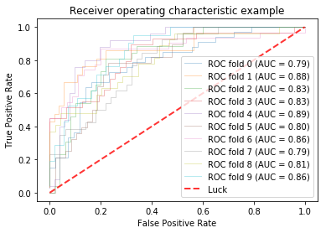

Breast Cancer:

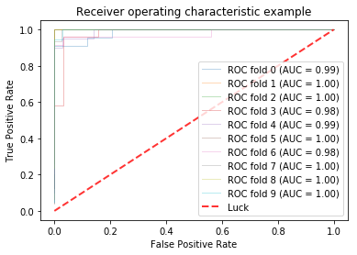

Spambase:

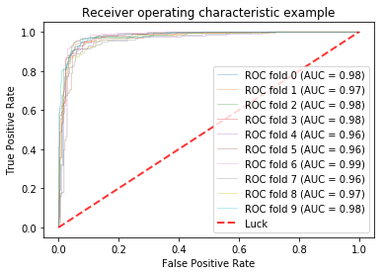

### RBF:

Diabetes:

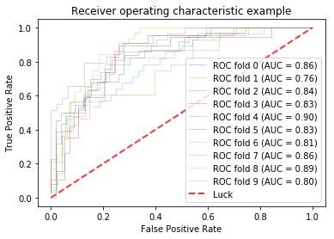

Breast Cancer:

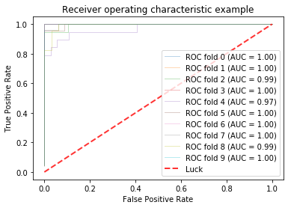

Spambase:

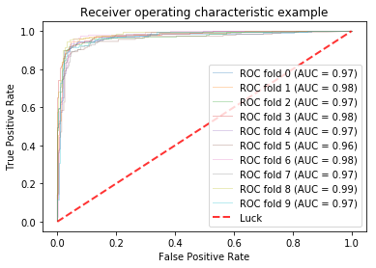

## By AUC:

### Linear:

Diabetes:

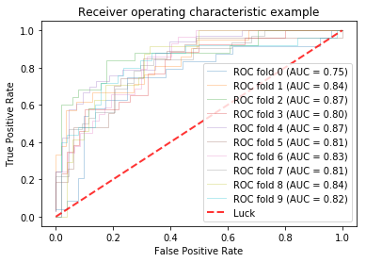

Breast Cancer:

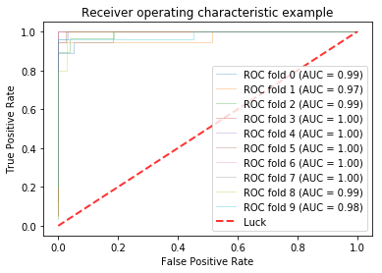

Spambase:

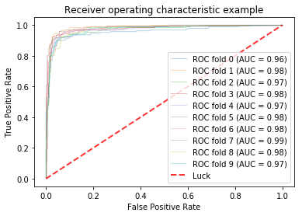

### RBF:

Diabetes:

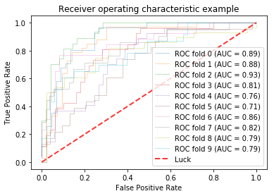

Breast Cancer:

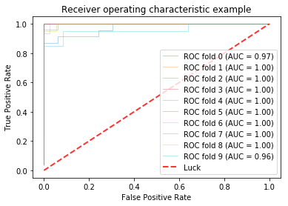

Spambase:



# 4 SVMs vs Multiclass Problems

1.

|  |  |  |  |  |  |
| --- | --- | --- | --- | --- | --- |
| Wine: Class1: | | Linear | | RBF | |
| Train | Test | Train | Test |
| Accuracy | Mean | 99.8% | 97.6% | 99.6% | 99.4% |
| Std | 0.3% | 3.9% | 3.04% | 1.76% |
| Precision | Mean | 99.1% | 97.5% | 98.6% | 97.5% |
| Std | 1.12% | 7.5% | 1.11% | 7.5% |
| Recall | Mean | 100% | 98.3% | 100% | 100% |
| Std | 0% | 5% | 0% | 0% |

|  |  |  |  |  |  |
| --- | --- | --- | --- | --- | --- |
| Wine: Class2: | | Linear | | RBF | |
| Train | Test | Train | Test |
| Accuracy | Mean | 99.8% | 98.8% | 99.8% | 98.2% |
| Std | 0.28% | 2.35% | 0.28% | 2.70% |
| Precision | Mean | 99.3% | 97.5% | 99.3% | 97.5% |
| Std | 1.02% | 7.5% | 1.04% | 7.5% |
| Recall | Mean | 100% | 98.5% | 100% | 98.5% |
| Std | 0% | 4.29% | 0% | 4.29% |

|  |  |  |  |  |  |
| --- | --- | --- | --- | --- | --- |
| Wine: Class3: | | Linear | | RBF | |
| Train | Test | Train | Test |
| Accuracy | Mean | 99.9% | 98.2% | 99.7% | 98.2% |
| Std | 0.25% | 2.7% | 0.31% | 2.70% |
| Precision | Mean | 99.5% | 98% | 98.9% | 97.1% |
| Std | 0.93% | 6% | 1.12% | 5.91% |
| Recall | Mean | 100% | 100% | 100% | 100% |
| Std | 0% | 0% | 0% | 0% |

## Linear:

Wine:

Class ID: 1

Fold: 0 C optimal: 0.5

Class ID: 2

Fold: 0 C optimal: 0.5

Class ID: 3

Fold: 0 C optimal: 0.0625

Class ID: 1

Fold: 1 C optimal: 0.5

Class ID: 2

Fold: 1 C optimal: 0.0625

Class ID: 3

Fold: 1 C optimal: 0.0625

Class ID: 1

Fold: 2 C optimal: 0.0625

Class ID: 2

Fold: 2 C optimal: 0.0625

Class ID: 3

Fold: 2 C optimal: 0.0625

Class ID: 1

Fold: 3 C optimal: 0.0625

Class ID: 2

Fold: 3 C optimal: 0.0625

Class ID: 3

Fold: 3 C optimal: 0.0625

Class ID: 1

Fold: 4 C optimal: 0.0625

Class ID: 2

Fold: 4 C optimal: 0.0625

Class ID: 3

Fold: 4 C optimal: 0.0625

Class ID: 1

Fold: 5 C optimal: 0.5

Class ID: 2

Fold: 5 C optimal: 0.0625

Class ID: 3

Fold: 5 C optimal: 0.5

Class ID: 1

Fold: 6 C optimal: 0.5

Class ID: 2

Fold: 6 C optimal: 0.5

Class ID: 3

Fold: 6 C optimal: 0.0625

Class ID: 1

Fold: 7 C optimal: 0.0625

Class ID: 2

Fold: 7 C optimal: 0.5

Class ID: 3

Fold: 7 C optimal: 0.0625

Class ID: 1

Fold: 8 C optimal: 0.0625

Class ID: 2

Fold: 8 C optimal: 0.5

Class ID: 3

Fold: 8 C optimal: 0.0625

Class ID: 1

Fold: 9 C optimal: 0.0625

Class ID: 2

Fold: 9 C optimal: 0.0625

Class ID: 3

Fold: 9 C optimal: 0.0625

## RBF:

Wine:

Class ID: 1

Fold: 0 C optimal: 4 gamma optimal: 0.03125

Class ID: 2

Fold: 0 C optimal: 256 gamma optimal: 0.0009765625

Class ID: 3

Fold: 0 C optimal: 4 gamma optimal: 0.0009765625

Class ID: 1

Fold: 1 C optimal: 4 gamma optimal: 0.03125

Class ID: 2

Fold: 1 C optimal: 256 gamma optimal: 0.0009765625

Class ID: 3

Fold: 1 C optimal: 4 gamma optimal: 0.0009765625

Class ID: 1

Fold: 2 C optimal: 0.5 gamma optimal: 0.03125

Class ID: 2

Fold: 2 C optimal: 32 gamma optimal: 0.0009765625

Class ID: 3

Fold: 2 C optimal: 0.5 gamma optimal: 0.03125

Class ID: 1

Fold: 3 C optimal: 32 gamma optimal: 0.0009765625

Class ID: 2

Fold: 3 C optimal: 32 gamma optimal: 0.0009765625

Class ID: 3

Fold: 3 C optimal: 4 gamma optimal: 0.0009765625

Class ID: 1

Fold: 4 C optimal: 4 gamma optimal: 0.03125

Class ID: 2

Fold: 4 C optimal: 4 gamma optimal: 0.03125

Class ID: 3

Fold: 4 C optimal: 0.5 gamma optimal: 0.03125

Class ID: 1

Fold: 5 C optimal: 0.5 gamma optimal: 0.03125

Class ID: 2

Fold: 5 C optimal: 4 gamma optimal: 0.03125

Class ID: 3

Fold: 5 C optimal: 0.5 gamma optimal: 0.03125

Class ID: 1

Fold: 6 C optimal: 4 gamma optimal: 0.03125

Class ID: 2

Fold: 6 C optimal: 4 gamma optimal: 0.03125

Class ID: 3

Fold: 6 C optimal: 0.5 gamma optimal: 0.03125

Class ID: 1

Fold: 7 C optimal: 4 gamma optimal: 0.03125

Class ID: 2

Fold: 7 C optimal: 0.5 gamma optimal: 0.03125

Class ID: 3

Fold: 7 C optimal: 0.5 gamma optimal: 0.03125

Class ID: 1

Fold: 8 C optimal: 4 gamma optimal: 0.03125

Class ID: 2

Fold: 8 C optimal: 4 gamma optimal: 0.03125

Class ID: 3

Fold: 8 C optimal: 0.5 gamma optimal: 0.03125

Class ID: 1

Fold: 9 C optimal: 0.5 gamma optimal: 0.03125

Class ID: 2

Fold: 9 C optimal: 32 gamma optimal: 0.0009765625

Class ID: 3

Fold: 9 C optimal: 4 gamma optimal: 0.0009765625

2，

## Linear:

Class1:

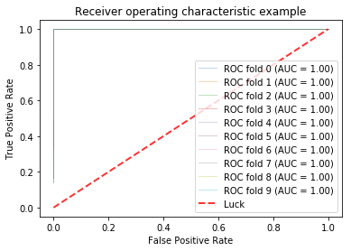

Class2:

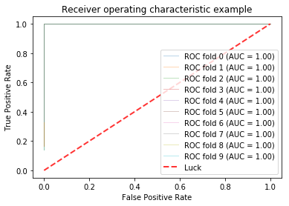

Class3:

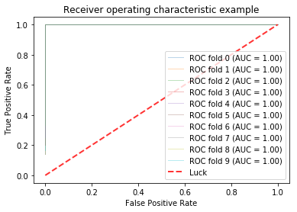

## RBF:

Class1:

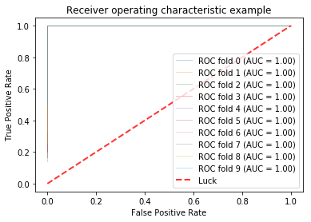

Class2:

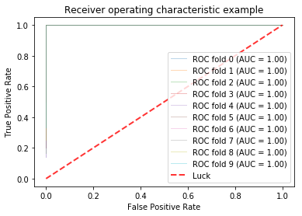

Class3:

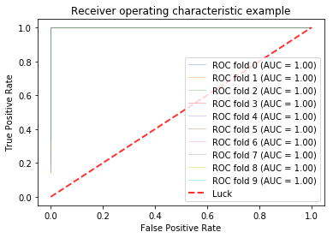

3,

## Linear:

C optimal: 0.5

gamma optimal: 1

Class ID: 0



Evaluation for training data:

Accuracy: 1.0

Precision: 1.0

Recall: 1.0

Evaluation for testing data:

Accuracy: 0.961046188091

Precision: 0.988826815642

Recall: 0.994382022472

Class ID: 1



Evaluation for training data:

Accuracy: 1.0

Precision: 1.0

Recall: 1.0

Evaluation for testing data:

Accuracy: 0.961046188091

Precision: 0.917525773196

Recall: 0.978021978022

Class ID: 2



Evaluation for training data:

Accuracy: 1.0

Precision: 1.0

Recall: 1.0

Evaluation for testing data:

Accuracy: 0.961046188091

Precision: 0.960451977401

Recall: 0.960451977401

Class ID: 3



Evaluation for training data:

Accuracy: 1.0

Precision: 1.0

Recall: 1.0

Evaluation for testing data:

Accuracy: 0.961046188091

Precision: 0.95

Recall: 0.934426229508

Class ID: 4



Evaluation for training data:

Accuracy: 1.0

Precision: 1.0

Recall: 1.0

Evaluation for testing data:

Accuracy: 0.961046188091

Precision: 0.983606557377

Recall: 0.994475138122

Class ID: 5



Evaluation for training data:

Accuracy: 1.0

Precision: 1.0

Recall: 1.0

Evaluation for testing data:

Accuracy: 0.961046188091

Precision: 0.923076923077

Recall: 0.989010989011

Class ID: 6



Evaluation for training data:

Accuracy: 1.0

Precision: 1.0

Recall: 1.0

Evaluation for testing data:

Accuracy: 0.961046188091

Precision: 0.983516483516

Recall: 0.988950276243

Class ID: 7



Evaluation for training data:

Accuracy: 1.0

Precision: 1.0

Recall: 1.0

Evaluation for testing data:

Accuracy: 0.961046188091

Precision: 0.988023952096

Recall: 0.921787709497

Class ID: 8



Evaluation for training data:

Accuracy: 1.0

Precision: 1.0

Recall: 1.0

Evaluation for testing data:

Accuracy: 0.961046188091

Precision: 0.969135802469

Recall: 0.902298850575

Class ID: 9



Evaluation for training data:

Accuracy: 1.0

Precision: 1.0

Recall: 1.0

Evaluation for testing data:

Accuracy: 0.961046188091

Precision: 0.955056179775

Recall: 0.944444444444

### RBF:

OCR:

C optimal: 4

gamma optimal: 0.0009765625

Class ID: 0



Evaluation for training data:

Accuracy: 0.99973842532

Precision: 1.0

Recall: 1.0

Evaluation for testing data:

Accuracy: 0.983305509182

Precision: 0.994413407821

Recall: 1.0

Class ID: 1



Evaluation for training data:

Accuracy: 0.99973842532

Precision: 0.997435897436

Recall: 1.0

Evaluation for testing data:

Accuracy: 0.983305509182

Precision: 0.957894736842

Recall: 1.0

Class ID: 2



Evaluation for training data:

Accuracy: 0.99973842532

Precision: 1.0

Recall: 1.0

Evaluation for testing data:

Accuracy: 0.983305509182

Precision: 1.0

Recall: 0.983050847458

Class ID: 3



Evaluation for training data:

Accuracy: 0.99973842532

Precision: 1.0

Recall: 1.0

Evaluation for testing data:

Accuracy: 0.983305509182

Precision: 0.983516483516

Recall: 0.978142076503

Class ID: 4



Evaluation for training data:

Accuracy: 0.99973842532

Precision: 1.0

Recall: 1.0

Evaluation for testing data:

Accuracy: 0.983305509182

Precision: 1.0

Recall: 1.0

Class ID: 5



Evaluation for training data:

Accuracy: 0.99973842532

Precision: 1.0

Recall: 1.0

Evaluation for testing data:

Accuracy: 0.983305509182

Precision: 0.978260869565

Recall: 0.989010989011

Class ID: 6



Evaluation for training data:

Accuracy: 0.99973842532

Precision: 1.0

Recall: 1.0

Evaluation for testing data:

Accuracy: 0.983305509182

Precision: 1.0

Recall: 0.994475138122

Class ID: 7



Evaluation for training data:

Accuracy: 0.99973842532

Precision: 1.0

Recall: 1.0

Evaluation for testing data:

Accuracy: 0.983305509182

Precision: 0.994186046512

Recall: 0.95530726257

Class ID: 8



Evaluation for training data:

Accuracy: 0.99973842532

Precision: 1.0

Recall: 0.997368421053

Evaluation for testing data:

Accuracy: 0.983305509182

Precision: 0.988095238095

Recall: 0.954022988506

Class ID: 9



Evaluation for training data:

Accuracy: 0.99973842532

Precision: 1.0

Recall: 1.0

Evaluation for testing data:

Accuracy: 0.983305509182

Precision: 0.941176470588

Recall: 0.977777777778